Use-Case Realization Report (Analysis)
Update Survey

Issue 1.0
Revision History
Date | Issue | Description | Author
01/Aug/09 | 1.0 | First Issue | Thomas Yap

Table of Contents
1. Brief Description 4
2. Flow of Events 4
2.1 Standard Flow 4
2.1.1 Update Survey 4
2.2 Exception 4
3. Interaction Diagrams 5
3.1 Collaboration Diagram for Update Survey 5
4. Participating Objects 5
5. Class Diagrams 6
5.1 Class Diagram for Update Survey 6
6. Derived Requirements 6

Use-Case Realization Report
Update Survey

Brief Description
This use case enables the controller to Update survey from Survey Pool. It involves displaying the menu and form for keying in the survey searchstrings or title list to update the record.

Flow of Events
The standard flow of events for this use case and any exceptions are described in the following subsections. The events are described in terms of Actors and Analysis Objects.

Standard Flow
This use case covers the Survey Maintenance - Update Survey. The standard flow of these events are described below.

Update Survey
The running of the application is shown in section 3.1. The flow of event is as follow:

- When the application start, the first operation to be performed is the startup operation of the main controller. This operation will create all the control objects and the entity objects necessary for operation Update Survey:
  - The control object created is: Survey Controller
  - The entity objects create are: Survey and Transaction Record

- The main controller will start the main function menu:
  - To start Update MCQ, operation FormDisplayMCQ is activated by MCQ Controller to display a MCQ form.
  - Use Case Display MCQ List will retrieve a title list of MCQ for Portal Admin to pick to be display on FormDisplayMCQ.
  - The use can then choose the object to modify. He/she will be redirected to the formMaintenance
  - Operation validate will validate the format of the entries.
  - Then MCQ Controller will check for additional criteria if any.
  - After the record is found and display on FormDisplayMCQ, Portal Admin is to change any details in the form. A confirmation request will be sent to the FormDisplayMCQ interface. Upon confirmation, the record will then be updated to file using operation update to entity object MCQ Table.
  - In addition, a transaction log of user and date will be recorder by operation insertRecord
  - The adding request can be cancelled and no data will be altered. In this case, a transaction record will still be created for traceability.
  - A confirmation message will be displayed by FormDisplayMCQ interface.

- Step 2 will be repeated until all deletions are completion. Then controller will terminate the application by issuing operation close.

Exception
None.

Interaction Diagrams

Collaboration Diagram for Update Survey
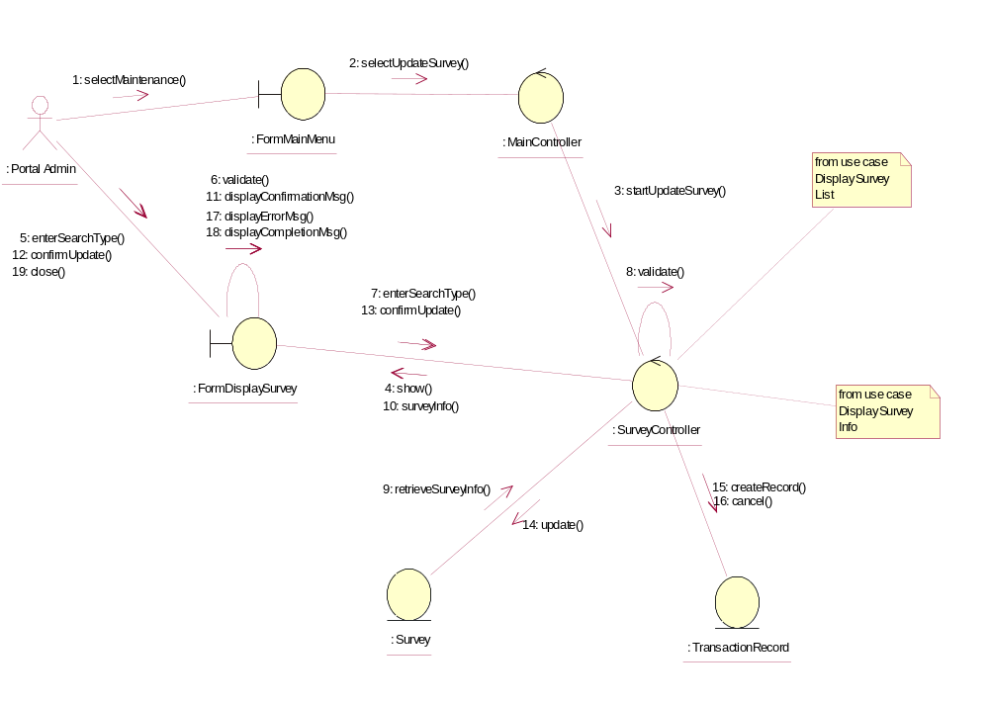

Participating Objects
: FormDisplaySurvey
This object is the interface for keying Surveys details.

: FormMainMenu
This is the main menu at the beginning of the application from where it can access the Survey Maintenance - Update Survey operation.

: MainController
This is the main controller that control the whole system.

: Portal Admin
This is the only actor that authorized to perform operation Survey Maintenance - Update Survey.

: Survey
This entity stores all the exam or exercise Surveys.

: SurveyController
This is the controller for Survey Maintenance. It creates and activates FormDisplaySurvey interface and Survey entity object.

: TransactionRecord
This is the entity object that created for transaction log and audit trail.

Class Diagrams

Class Diagram for Update Survey
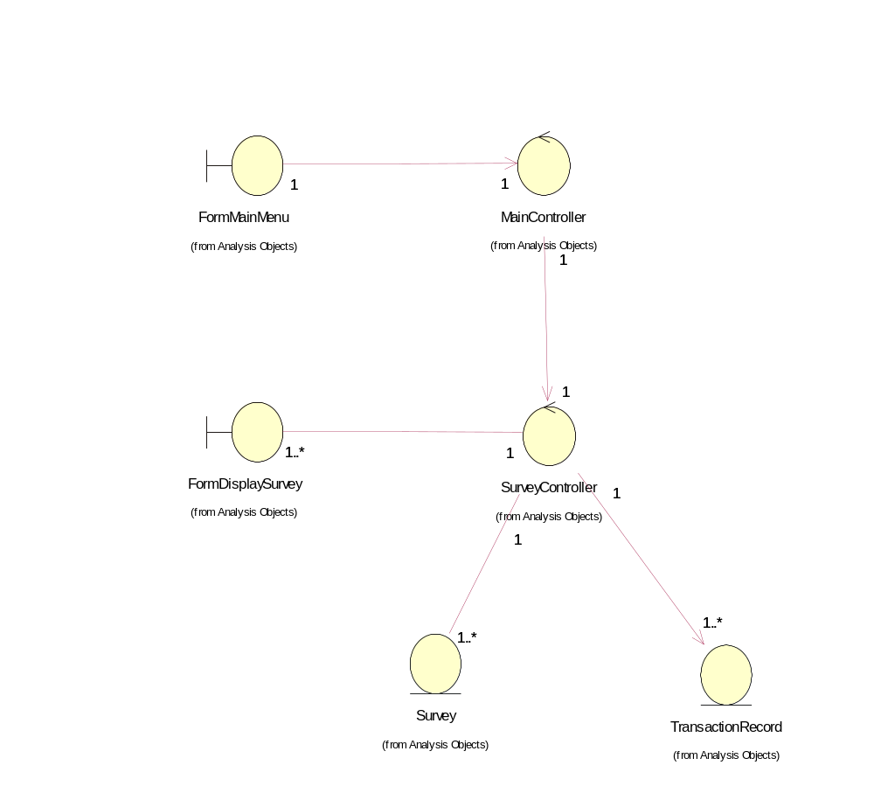

Derived Requirements
The FormMainMenu and FormDisplaySurvey Interface should have the format specified in User Requirements Specification for Content Management Portal.

